To manipulate the peripheral using the AXI protocol, it was integrated to internally contain the minimum necessary registers for peripheral control and two ports that will connect with the outside world, as shown in figure 1.
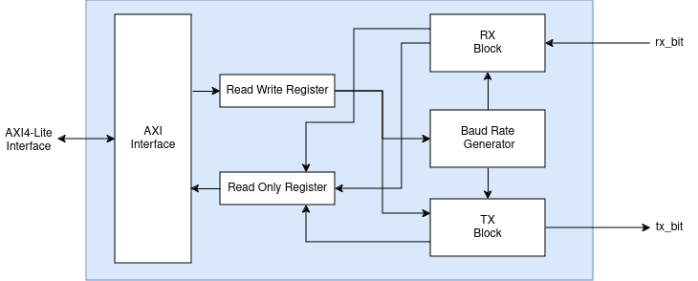
Figure 1 - UART with AXI4Lite Interface Overview

In the construction of the IP module, two registers were defined: a read-only register at address 0x0 and a read-write register at address 0x4.
In the first mentioned register, the bits for the content of the receive register (Rx) are contained, along with bits indicating when transmission on the tx_bit and reception on the rx_bit end. On the other hand, in the write register, the input value for the baud rate generator, the content of the transmit register (Tx), and the control bits to turn on and off the UART for both transmission (Tx) and reception (Rx) are contained. Figure 2 depicts the organization for each.
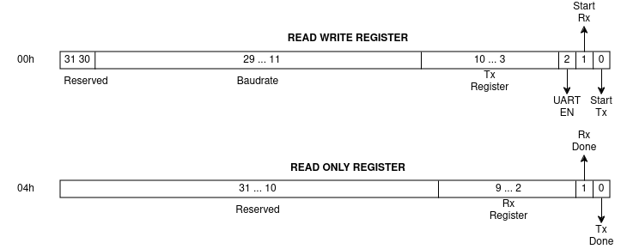
Figure 2 - IP slave registers

For this module, an interface was also created to be used by the master, containing three different processes: baud rate configuration, reading the Rx register buffer, and transmission through the tx port.
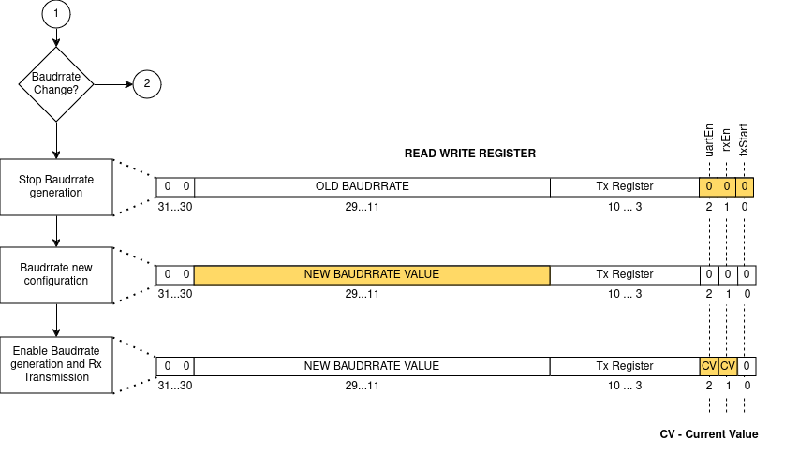
Figure 3 - Baudrate configuration process
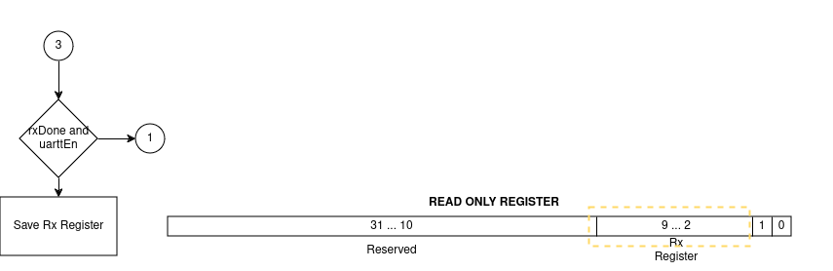

Figure 4 - Read Rx Register process
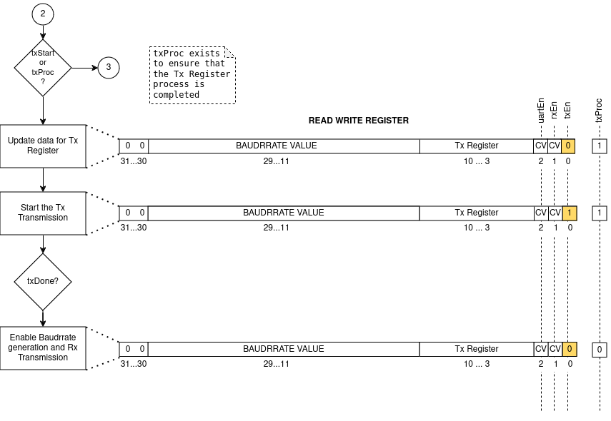

Figure 5 - Tx Port Transmition process

Several simulations were conducted to validate and conclude the intended results. Below in figure X, a simulation was performed in the Vivado environment where, on two occasions, a character was received at the Rx port and then forwarded to the Tx port, ending with the transmission of this last character three times. This final step was to verify that if the txStart bit remains active, it will cause the last value written to the Tx register to be sent.
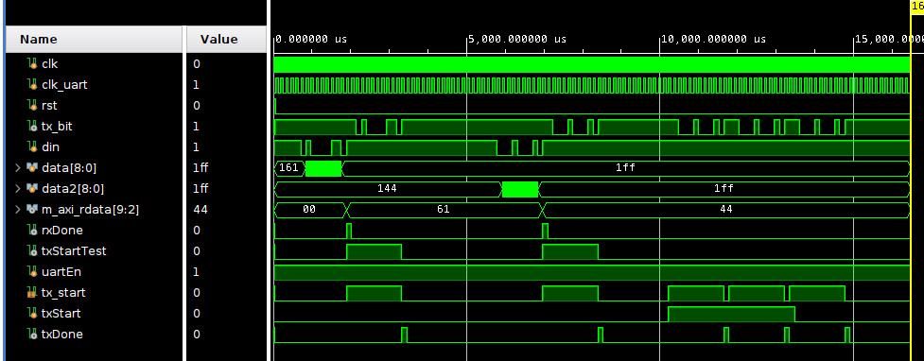
Figure 6 - Post-Synthesis functional Test Bench
After generating the bitstream for the Zybo Z7-10 board, external software was used to verify the reception and transmission of data. Figures X and X demonstrate the behavior previously defined.
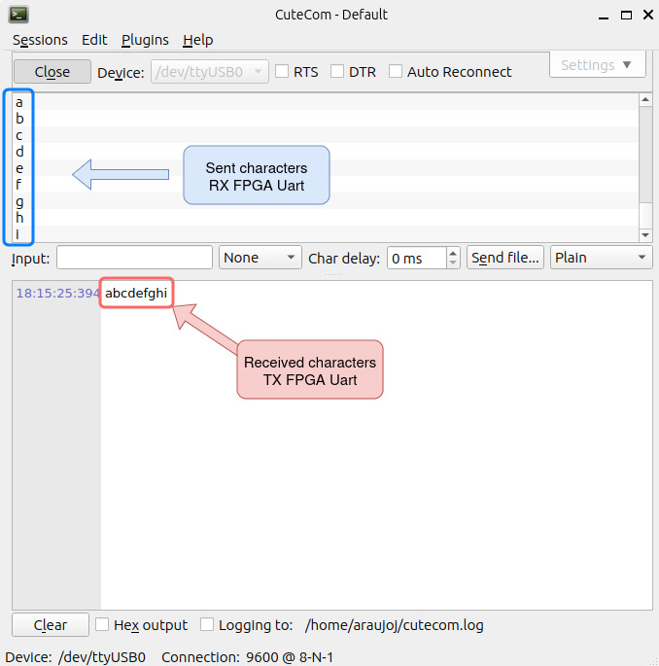
Figure 7 - Reception and transmission test, using CuteCom to visualization

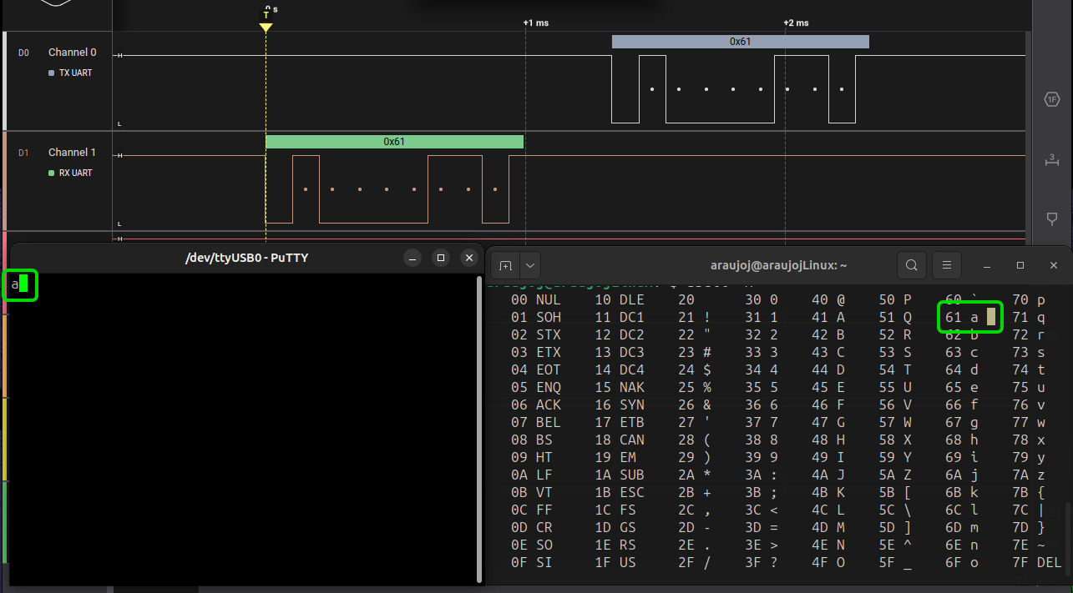
Figure 7 - Validation of data value sent

